from tkinter import *  
  
root = Tk()  
root.title("Login UI using Pack")  
root.geometry("400x320") # set starting size of window  
root.maxsize(400, 320) # width x height  
root.config(bg="#6FAFE7") # set background color of root window  
  
login = Label(root, text="Login", bg="#2176C1", fg='white', relief=RAISED)  
login.pack(ipady=5, fill='x')  
login.config(font=("Font", 30)) # change font and size of label  
  
# login image  
image = PhotoImage(file="hangoutt.png")  
img_resize = image.subsample(5,5)  
Label(root, image=img_resize, bg="white", relief=SUNKEN).pack(pady=5)  
  
def checkInput():  
 *'''check that the username and password match'''* usernm = "y"  
 pswrd = "p"  
 entered_usernm = username_entry.get() # get username from Entry widget  
 entered_pswrd = password_entry.get() # get password from Entry widget  
  
 if (usernm == entered_usernm) and (pswrd == entered_pswrd):  
 root = Tk()  
 root.title("Login UI using Pack")  
 root.geometry("400x320") # set starting size of window  
 root.maxsize(400, 320) # width x height  
 root.config(bg="#6FAFE7")  
 Label(root, text="Have Fun", bg="#6FAFE7").pack(side='left', padx=7)  
  
 else:  
 print("Login failed: Invalid username or password.")  
  
def toggled():  
 *'''display a message to the terminal every time the check button  
 is clicked'''* print("The check button works.")  
  
# Username Entry  
username_frame = Frame(root, bg="#6FAFE7")  
username_frame.pack()  
  
Label(username_frame, text="Username", bg="#6FAFE7").pack(side='left', padx=5)  
  
username_entry = Entry(username_frame, bd=3)  
username_entry.pack(side='right')  
  
# Password entry  
password_frame = Frame(root, bg="#6FAFE7")  
password_frame.pack()  
  
Label(password_frame, text="Password", bg="#6FAFE7").pack(side='left', padx=7)  
  
password_entry = Entry(password_frame, bd=3)  
password_entry.pack(side='right')  
  
# Create Go! Button  
  
go_button = Button(root, text="GO!", command=checkInput, bg="#6FAFE7", width=15)  
  
go_button.pack(pady=5)  
  
# Remember me and forgot password  
bottom_frame = Frame(root, bg="#6FAFE7")  
bottom_frame.pack()  
  
var = IntVar()  
  
remember_me = Checkbutton(bottom_frame, text="Remember me", bg="#6FAFE7", command=toggled, variable=var)  
remember_me.pack(side='left', padx=19)  
  
# The forgot password Label is just a placeholder, has no function currently  
forgot_pswrd = Label(bottom_frame, text="Forgot password?", bg="#6FAFE7")  
forgot_pswrd.pack(side="right", padx=19)  
  
root.mainloop()

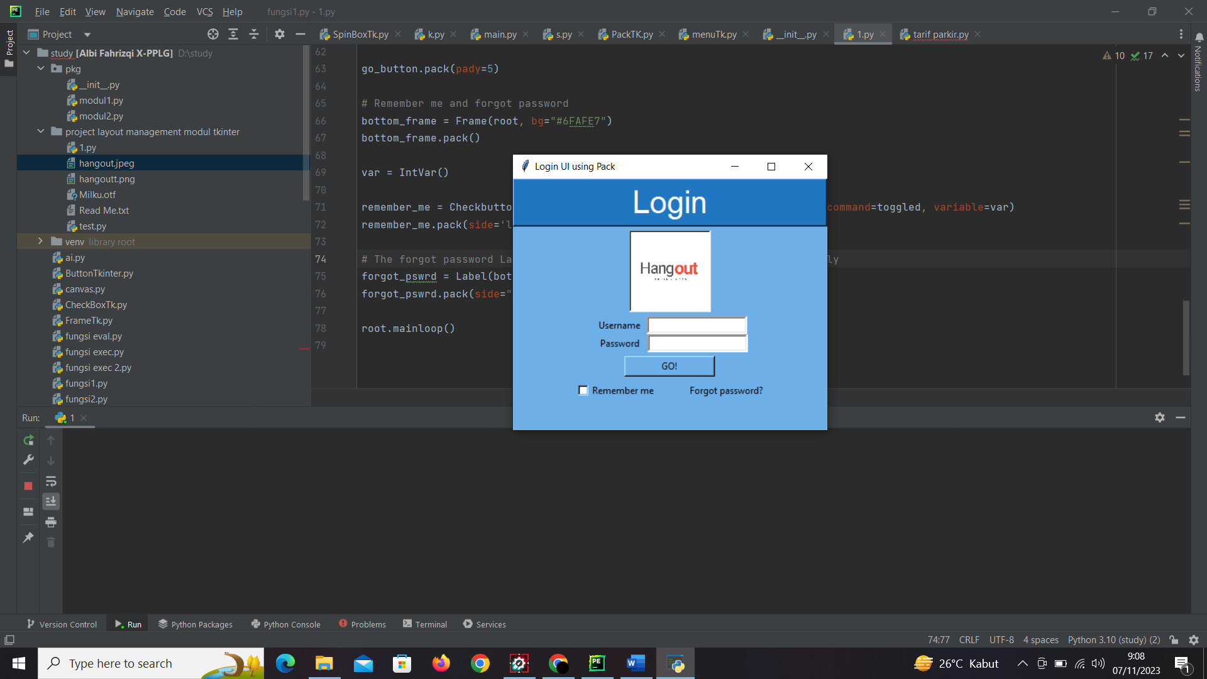

**Kelompok 1 :**

* Albi
* Luthfi
* Andiya

Deskripsi : tampilan login untuk aplikasi hangout, aplikasi ini dibuat menggunakan python tkinter.

